Midterm 2, Winter 2020 Answer Key

Short Answer

ABO blood type gives the type of blood antigen. It is primarily determined by a gene with alleles I^{A,} I^{B,} and ii. I^{A} and I^{B} are codominant, I^{A} is dominant to i, I^{B} is dominant to i, and ii gives an O blood type. There is a separate locus (H) that controls the production of these antigens. Individuals that are homozygous hh cannot produce any antigens and appear to be O-type.

Consider the following cross:
I^{A}iHh x I^{B}iHh
What are the expected frequencies of the apparent blood groups among the offspring?

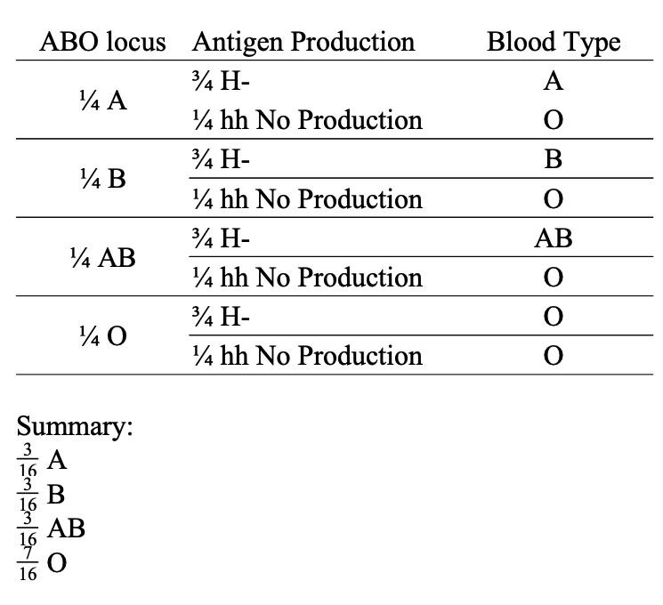

In the fruit fly, recessive mutations in either of two independently assorting genes, brown and purple, prevent the synthesis of red pigment in the eyes. Thus, homozygotes for either of these mutations have brownish-purple eyes. However, heterozygotes for both of these mutations have dark red, that is, wild-type eyes. If such double heterozygotes are intercrossed, what phenotypes will be observed in the progeny and in what proportions?

9/16 dark red, 7/16 brownish purple

Extended Calculations

You are interested in identifying SNPs associated with diabetes. You conduct a case-control study using 500,000 SNPs. The genotype frequencies at one of the SNPs between cases and controls are listed below:
 | GG | GT | TT
Case | 661 | 255 | 20
Control | 724 | 354 | 50
Using a chi-square test, determine if there is a significant association of this SNP with diabetes. Show your work. Include the chi-square statistic, the degrees of freedom, and the p-value.
Given your p-value, does this SNP have a significant association with diabetes?

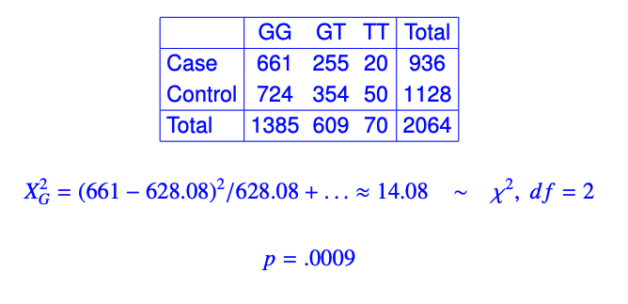

With 500,000 SNPs tested, threshold is 0.05/500,000, so there is no significant association.

The following shows a reciprocal translocation. In an individual that is heterozygous for this translocation, where the homologous chromosomes are normal,
(a) draw the chromosomes that would be found in gametes after meiosis due to Alternate segregation.
(b) draw the chromosomes that would be found in gametes after Adjacent-1 segregation
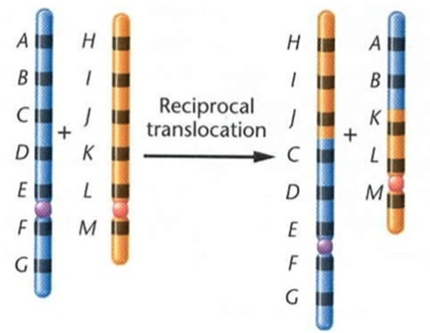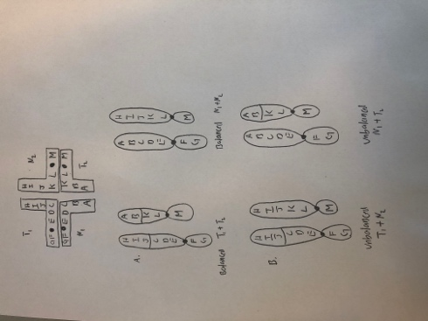

The Micronesian Kingfisher, Halcyon cinnamomina, has a cinnamon-colored face. In some birds, the color continues onto the chest, producing one of three patterns: a circle, a shield, or a triangle; in other birds, there is no color on the chest. A male with a colored triangle was crossed with a female that had no color on her chest, and all their offspring had a colored shield on the chest. When these offspring were intercrossed, they produced an F2 with a phenotypic ratio of 3 circle: 6 shield: 3 triangle: 4 no color.
This trait is determined by the genetic interaction of two genes.
Determine the type of genetic interaction (e.g. reciprocal recessive epistasis, recessive epistasis, dominant epistasis, etc)
Indicate the genotypes and their genotype ratio for all the F2 progeny. For one of the genes, use the alleles A and a and use the alleles B and b for the other gene.
